# Order Entry

1. Log into Vendor Portal

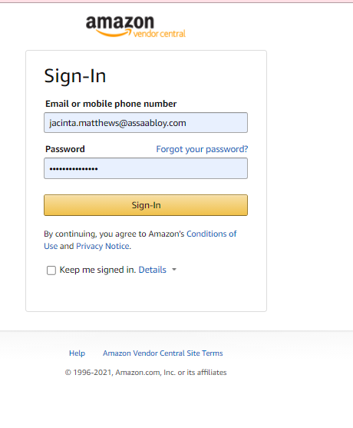

1. Select Orders > Purchase Orders > Confirm New POs

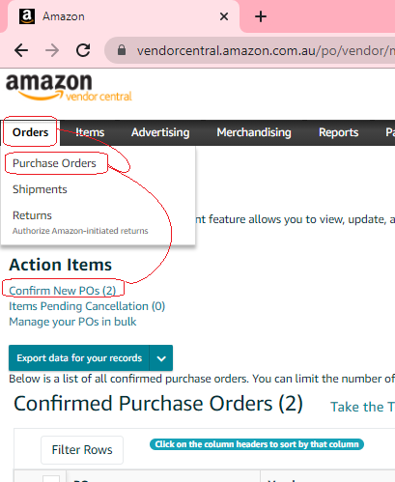

1. 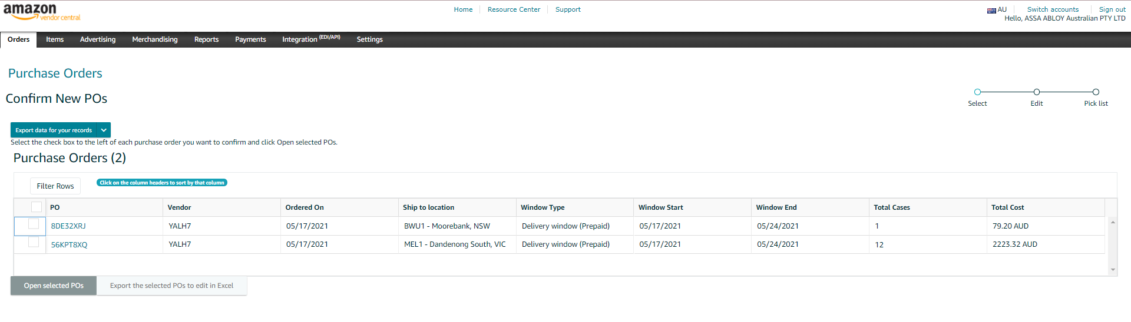Select PO
2. Enter into AX, confirm details.
3. Select Item on Vendor Portal, and Update Selected Items

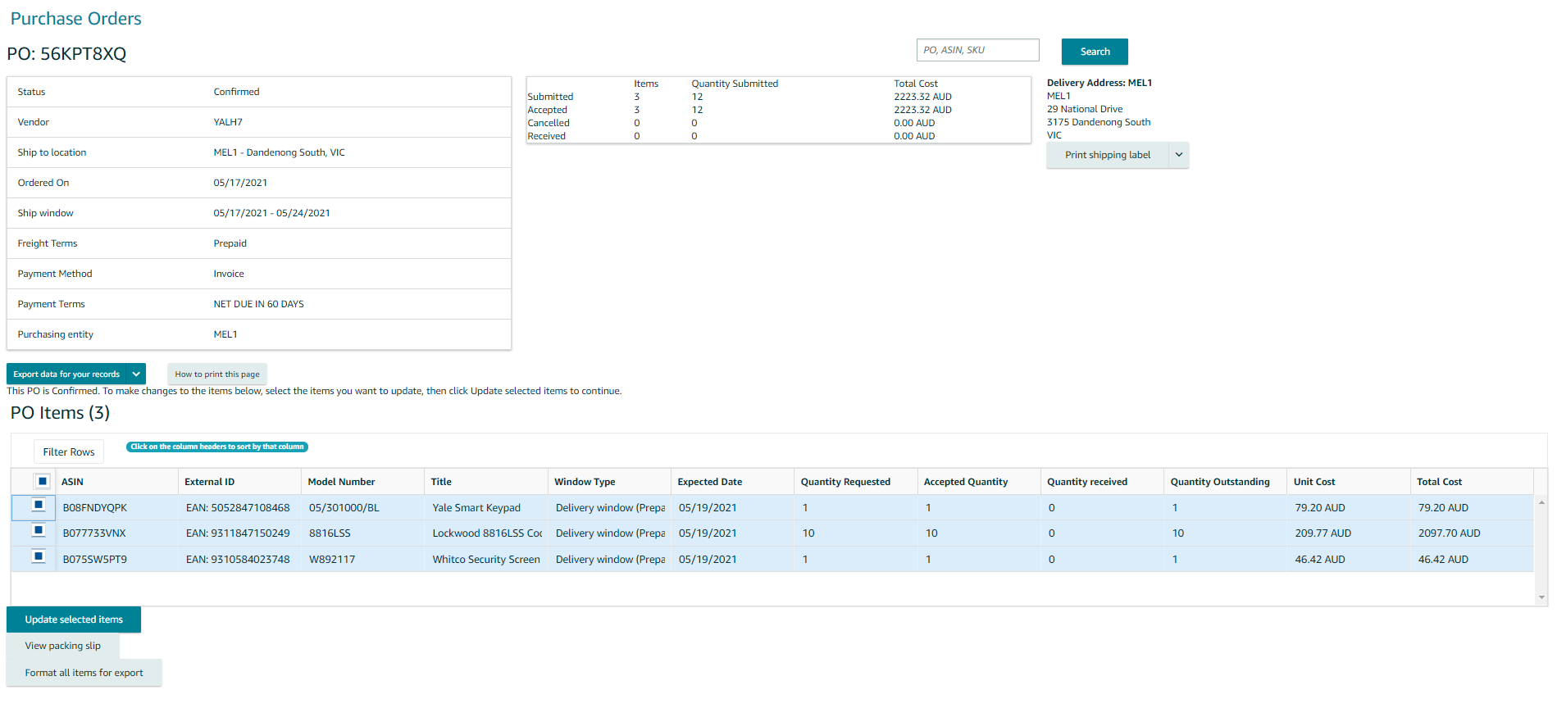

1. Update as required.  
   Items in Yellow can be updated.
2. Print Shipping Labels to send to Warehouse.

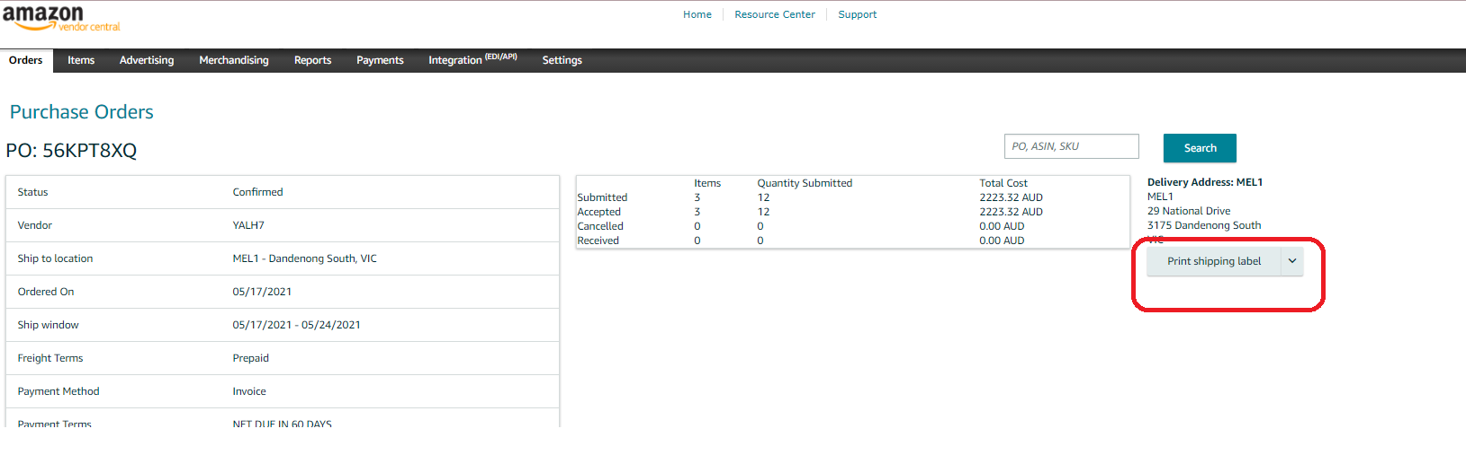

1. Email Warehouse Order #s and copy of shipping labels for dispatch.

# Shipment Entry

1. Log into Vendor Portal
2. Select Orders > Shipments

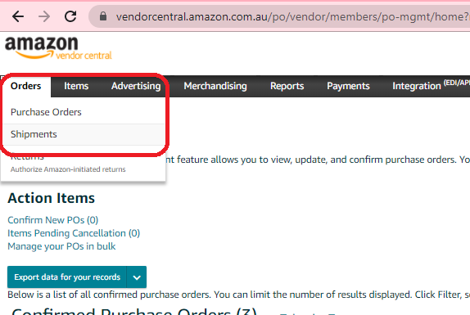

1. Select Submit ASN
2. Select PO > Click Next

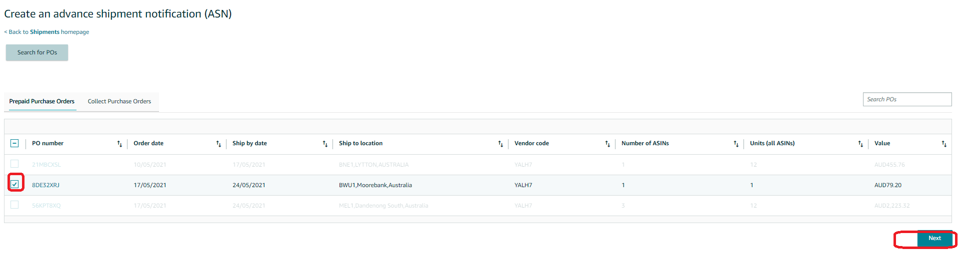

1. Include information as per the order shipment

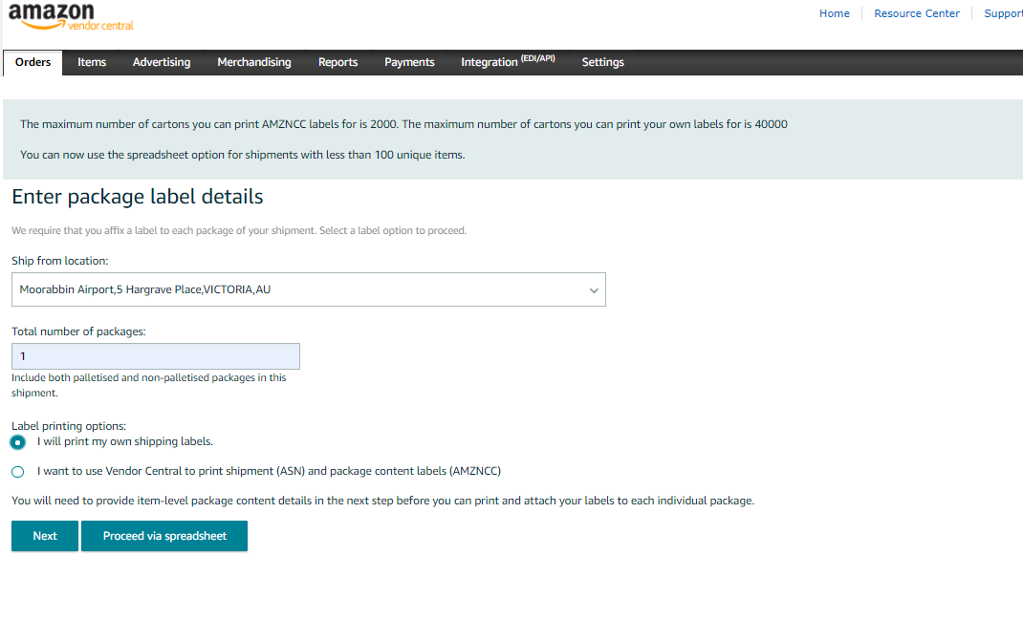

1. Include information as per the order shipment

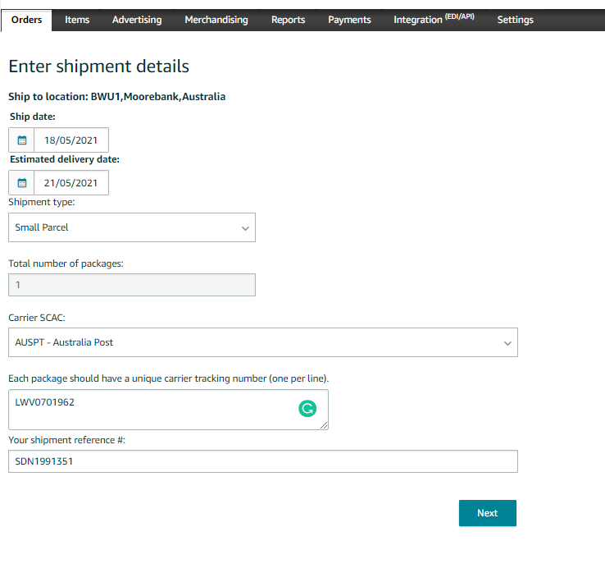

1. Select items to ship
2. Review and Submit